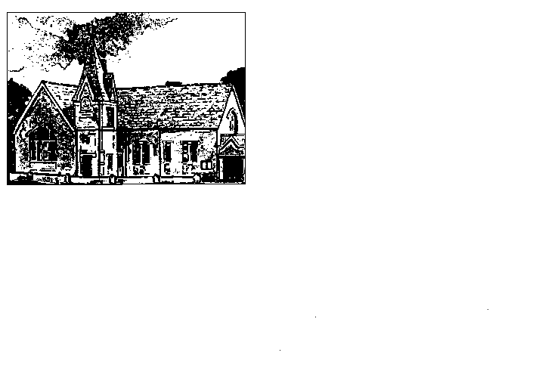
Harston and Newton Primary School

Application for Leave of Absence during Term Time

Please note the following before completing this form and read the information overleaf carefully.

The Education (Pupil Registration) (England) (Amendment) Regulations 2013: Regulation 7 of the 2006 Regulations is amended to prohibit the proprietor of a maintained school granting leave of absence to a pupil except where an application has been made in advance and the proprietor considers that there are exceptional circumstances relating to the application.

Pupil’s Name |  |  |  | Date of Birth |  |  |  | Class/Teacher
Home Address

First Date of Absence |  |  |  | Date of Return |  |  |  | No. of School Days Absent
Exceptional Reason for Absence:

Name of Parent |  |  |  | Home Tel. No. |  |  |  | Mobile Tel. No.
Email address :

Signature of Parent:

For the Headteacher to complete
Date received:
Current Attendance: % |  |  |  |  |  | Last Year’s Attendance %
Exceptional Reason Accepted |  |  |  |  |  | Yes / No
Name and Signature |  |  |  |  |  | Date
If you still intend to take the holiday, please know that the absence has been
authorised / unauthorised (delete as appropriate)

Application for Leave of Absence during Term Time

Harston and Newton Primary, the Local Authority and Government believe that absence during term time should be avoided as it can have a damaging effect on a pupil’s education and overall achievement. However, it is recognised that there may be exceptional reasons that may justify authorisation of the absence by the Headteacher.

The Education (Pupil Registration) (England) (Amendment) Regulations 2013 explanatory note states:

As a result of the changes on 19th August 2024 we have revised our Attendance Policy, which from 1st September 2024 will include the following:

- Application is to be made in advance by the parent with whom the child normally resides on the form headed ‘Application for leave of absence during term time.’
These may be obtained from the school office.

- Leave of absence will only be granted where the Headteacher considers it is due to ‘exceptional circumstances’. Parents will be informed within 7 school days as to whether the request has been authorised or unauthorised.

- If a pupil takes unauthorised term-time leave for 10 consecutive sessions or more (generally 5 days) they will be subject to a Penalty Notice. The fine for a penalty notice is £80 per child, per parent/carer, increasing to £160 if not paid after 21 days but within 28 days for pupils who are of statutory school age.

- If a penalty notice remains unpaid, parents may be the subject of court proceedings for failing to ensure the regular school attendance of their child and this could result in a fine of up to £2,500 and/or a term of imprisonment of up to 3 months per parent.

- For second offences of unauthorised term-time leave (10 consecutive sessions or more) within a three-year rolling period, the fine is a flat £160 per parent, per child.

- For the third offence in a three-year rolling period, the referral will be automatically considered for prosecution in relation to Section 444 Education Act 1996.

NB The word ‘parent’ for the purposes of attendance includes anyone who lives with the child and has day to day care of that child. This is in addition to legal guardians and those with parental responsibility.

